Report by: 1409046  
Role: Level Design & Artist liaison

Game Version: Latest – with Menus  
Date Reported: 26/04/2016

QA Status: Passed

Severity: High

Priority: Game Breaking

Test Introduction:

The purpose of this test was to see if the main menu was correctly linked to the vehicle select and then in turn linked to the corresponding level. To test this, I started the game from the ‘Main Menu’ scene and tried to play through from there.

Expected outcome:

I expected the levels to load exactly the same as if I were playing the scene directly from the editor.

Actual outcome:

When I loaded the main menu scene, the links to everything from this worked correctly. When selecting the first ship the scene loaded but there was no ship model in the scene and the console was displaying a message indicating the ship had been destroyed.

Screenshot of the bug:

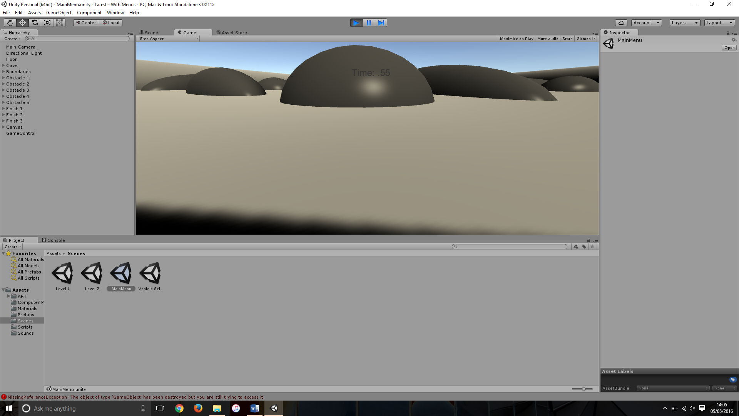

Image comparison showing the level loaded without the ship game object.

Potential cause:

A potential cause of this could be that because the ship is destroyed when its velocity is 0 it destroys the game object. The player movement script could initialise the object to spawn as soon as the game is loaded, this would lead the ship to have 0 velocity until the player reached the scene.

Suggested Fix:

To fix this bug we had to enter the player movement script and change ‘if (planeRigidbody.velocity.z < 1 && Time.time > 1.0f)’ to ‘if (planeRigidbody.velocity.z < 1 && Time.timeSinceLevelLoad > 1.0f)’, this was executed by Adam Laston with the help of me, Adam Brewster and Kristiyan D Kovachev.